Virtual Church

How to set up your church to stream Mass, do virtual meetings with parishioners, and perform collections.

By Kevin Benz, Jacqui Orgovan, Mary Dickins, Theresa Galvez, Salvador Osorio, Deanna Martinez, Rebecca Martinez, and David Karle

**Table of Contents**

A summary of how to set up Virtual Church 3

Virtual Mass 4

Overview 4

Scheduling the event, so people know where to watch it 4

People You Will Need To Setup 4

The basic setup 4

The Streaming PC/MacBook 5

Camera and Tripod 6

Parish Sound System 7

WiFi Network 8

Streaming Live Video. Also, Saving Video for later Streaming 8

Schedule an Event 9

Virtual Host/Usher – They Host the Event 9

Virtual Moderators - Helpers with Smartphones/Tablets and Handling Commentary 9

Testing and Adjusting 9

Rehearsing 10

Virtual Parishioner Visits 11

Overview 11

The Room 11

A PC/Mac 11

Smartphones – Android and/or Apple 11

Virtual Collections 12

Virtual Collections Platforms 12

Appendix 13

FaceBook Setup 13

Vimeo Setup 22

YouTube Setup 23

Camera Setup 24

Audio Setup 25

Checklists 27

Troubleshooting 28

# A summary of how to set up Virtual Church

In this time of trial, many parishes are struggling with how to stay connected to their homebound parishioners. This is a guide on how to do just that, at little or no cost, and without requiring specialized technical knowledge.

This is a guide on how to set up your church to do four things.

1. **Virtual Mass:** Run a Virtual Mass so your faith community can attend Mass from their homes
2. **Virtual Parishioner Visits:** Have the priest perform virtual visits with parishioners. The father can then do one on one calls with parishioners from the safety of church with the parishioners who are self-quarantines in their homes.
3. **Virtual Collections:** The church can still run collections to support its efforts to help the needy.
4. **Other Ways to connect virtually:** Other apps and tools that you can use to help build your faith ministry.

# Virtual Mass

## Overview

The most important thing that can be done right now is setting up Virtual Mass, so the Word of God can be brought to parishioners while they are stuck in self-quarantine. This section is a guide on how to setup and run Virtual Mass.

## Scheduling the event, so people know where to watch it

This guide is based on the presumption that Facebook is the primary tool for connecting with your parishioners. Most older parishioners use Facebook to connect with their families, and Facebook offers several features that help with Virtual Mass, so it is the easiest to use social media platform for the average parishioner.

## People You Will Need To Setup

Gather your church videographer, the sound person, and someone who has both the Feacebook page password as well as the [administrator password](https://www.lifewire.com/how-do-i-find-the-windows-administrator-password-2626064) for the streaming computer.

## The basic setup

The basic setup is very simple and is designed to make sure the Mass can both be streamed live on Facebook and also be easily available as a saved video for later. While there are more complicated ways of setting up virtual Mass, this basic setup requires the following:

1. A Windows PC/Laptop or Apple MacBook that is dedicated to being used at Mass and Captures/Streams the video and audio. You need the administrator password for a PC!
2. 1-3 helpers with personal smartphones or tablets
3. A camera and a tripod
4. The parish sound system with a couple of extra cables
5. A WiFi Network
6. A parish Facebook page. You need the password!

### Diagram of Setup

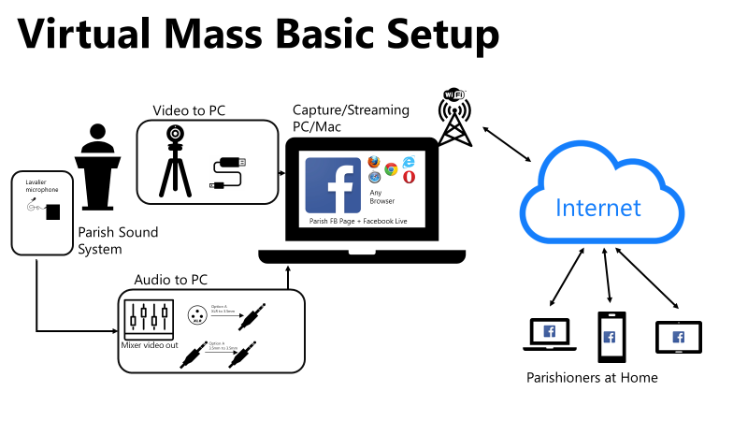

## The Streaming PC/MacBook

The easiest way to stream live audio and video to Facebook, Vimeo, or YouTube is thru a PC, Laptop, or MacBook. Most parishes have desktop computers or laptops; you just need to bring one of these into the church and set up on a table in the central aisle. Alternatively, see if a parishioner has a MacBook, laptop, or desktop that they can donate for a few weeks.

This is important. Once the computer is in place, don’t move it! Every time you remove one of the components for this setup, you risk it not working for the next Mass! It is better to put all of the equipment in place and leave it!

**Smartphones or Tablets as Streaming Capture Device:** A note on using smartphones/tablets for Virtual Mass in lieu of a computer. Computers have more processing power than smartphones or tablets. They have more horsepower. Plus they have more USB and other ports to plug in microphones and cameras. It is possible to do Virtual Mass with a smartphone or tablet, but it is more work. Email me and I’ll write it up for you. BUT, the best way is to use a computer.

Now sign into the computer. Make sure the password or pin is written down somewhere so everyone can sign in!

Load a browser window or start the Facebook app. Sign into the church Facebook page. Go to the Appendix to find technical information on how to set up Facebook.

Go into Facebook setting, make sure that the audio is coming from the Parish Sound System <see the Parish Sound System Section>, and that video is coming from the Camera and Tripod <see the Camera and Tripod Section>

Start a Facebook live video, and you are ready to stream!!!

## Camera and Tripod

For this, you need at least one of the following types of cameras and a tripod.

A **webcam** OR a **standard camera that can stream to a video out cable** like a **modern DSLR** or **Video camera**

All webcams can stream to a USB cable. Plug it into your PC/MacBook and download the driver. Most DSLRs or Video cameras can do the same thru USB. You might need a video capture card to do those cameras, which is why a webcam is preferable now.

Plug it in, go to Facebook Live, go into Settings, and check to make sure you can see that the camera is working!

## Parish Sound System

This is the real key to Virtual Mass. Most parishes have a sound system with body-worn wireless microphones that feed into a mixer box. The mixer box looks like this.

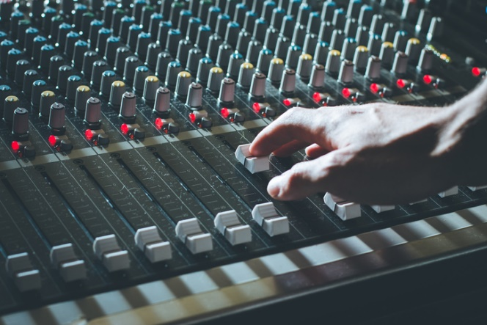

Now, this is important. Many parishes will try to use their built-in microphones at the altar. DON’T! The sound quality will be terrible! There will be lots of echo and other sound issues.

Instead, use the wireless lavalier microphones that are already part of the system. They look like this.

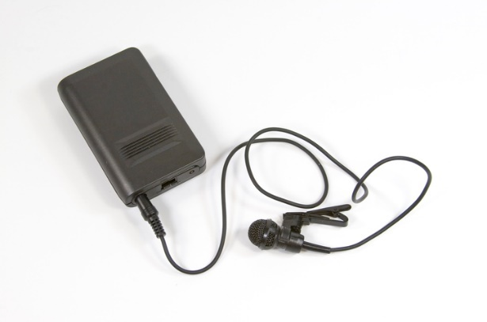

The only thing you need to do to take advantage of this is to find the audio out port on the Sound Mixer and run a cable from it to the streaming/capture PC. That’s it. One measly cable! Usually, there will be either an XLR out port on the mixer or a 3.5mm (1/4 in) out port on the mixer.

The XLR looks like this.

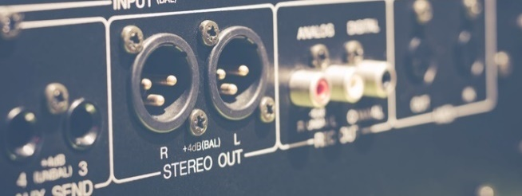

The 3.5mm looks like this.

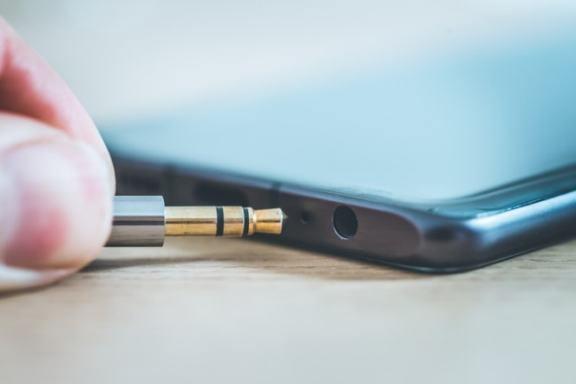

If you have a 3.5mm/ 1/4 in port, you just run that type of cable from mixer to the PC.

If you have the XLR out, run an XLR cable to the PC, and then you will need an XLR to 3/5mm / 1/4in adapter.

Go to the Audio setup to find out more on where to get these cables and how to set this up.

Once this is done, go to Facebook settings and make sure that the lavalier microphones work!

## WiFi Network

Last you will need a standard Wi-Fi connection to the internet for then PC/MacBook. Nothing fancy.

## Streaming Live Video. Also, Saving Video for later Streaming

Now sign into Facebook, and you can choose the Live video option if you are signed into the Parish Facebook Page, and you should be able to livestream the video and audio! For those of you that want to use Video or YouTube, please go to the Appendix to find out more. Those are all good options. You are ready to start streaming Mass.

Once you start streaming, Facebook will also automatically save you video to the Facebook post, so parishioners who missed the livestream can see it later.

## Schedule an Event

Now you need to let people know when you will be streaming Mass.

On the Parish Facebook page, go to events and schedule Mass for everyday, so everyone knows you will be having Mass! No one will come unless they know you are having services!!!

## Virtual Host/Usher – They Host the Event

Appoint one person who is not going to be taking part in the Mass as the virtual usher. Have them stand at the streaming/capture PC and manage the livestream. They should not only make sure that the livestream is working, but they should act like an usher and announce Mass is about to art, give a countdown, and act as the director of the show!

## Virtual Moderators - Helpers with Smartphones/Tablets and Handling Commentary

Have 1-3 parishioners sign into Facebook on their smartphones/tablets and navigate to the livestream. These people can do two things. First, they will tell you if there are any problems with the livestream and can walk their phone over to the usher to show what the problem is. Second, they can handle the comments section and respond to comments which frees up the usher to focus on the livestream

## Testing and Adjusting

1-2 days ahead of the first Virtual Mass, bring the priest, the virtual usher, the helpers, and all of the technical people together to setup the equipment and test it. THIS IS CRITICAL!

Setup everything. The camera, the audio, the streaming/capture PC on the table, all of the cabling. Once everything is set, put the lavalier microphone on the father and test it. Have the helpers view from the smartphones in a hallway to make sure the sound and video quality are good. Make sure to test all sound that you will be using, not just father.

Once you confirm everything works, LEAVE IT IN PLACE! Every time you plug and unplug equipment, you run the risk of breaking the environment and having to start all over again. Also, get Gaff tape and tape down all of the cables and connections, so they don’t come undone and so people don’t trip on the cords.

## Rehearsing

It’s always good to do a fun Mass rehearsal the first few times you do this. Adjust, iterate, adjust.

# Virtual Parishioner Visits

## Overview

Now that you have Virtual Mass up and running, it’s time to setup Virtual Parishioner Visits. As of this writing, there is not a dispensation to allow for virtual confession, but there is still a need for the priest to reach out and talk to parishioners who are homebound.

## The Room

Setup a private room where the priest can sit comfortable and talk with the parishioner. Someplace with good light and where the priest can talk without being overheard.

## A PC/Mac

Having a PC or Mac is also a good idea. Many parishes will not have extra equipment, but if the parish does, set aside a laptop or MacBook for the priests use, have him sign into Facebook from the Parish Page, and he has the ability to Facebook Voice and Video Calls from the Facebook Messaging app.

## Smartphones – Android and/or Apple

Another option is to use a smartphone. In a perfect world, the priest would have both an Android phone like a Samsung phone AND an Apple iPhone. The reason for this is simple. If the priest wants to do a video chat with a parishioner, he needs to use a different app depending on what phone he has. THIS IS IMPORTANT because the parishioner might have an Android phone and will using Google Duo. So the priest would need the same. Or if the parishioner has an iPhone, they use Apple’s FaceTime app. Apple’s FaceTime and Google’s Duo CANNOT talk to each other, which is why the priest needs both types of phones.

Also, make sure Facebook is setup as the priest can use the video call function of the messaging app to talk to parishioners regardless of device type.

# Virtual Collections

Last, how do you run virtual collections? We can’t get food to the needy if we have no way of buying that food. Fortunately, there are a number of Virtual Collections applications out there. Here is a quick overview.

All you need to do is decide which app to use, sign up, and then share a link in your virtual mass Facebook post.

## Virtual Collections Platforms

The best appears to be Tithe.ly. There are numerous reviews [here](https://www.capterra.com/sem-compare/church-management-software?utm_source=bing&utm_medium=cpc).

# Appendix

## FaceBook Setup

Every parish should have a Parish Facebook page. Find out who is an administrator, and you will need to add the parish priests, the helpers, and the virtual ushers as administrators FROM THEIR PERSONAL FACEBOOK accounts. This way, when they sign into their PERSONAL FACEBOOK they can navigate over to the PARISH PAGE and do posts and livestream.

All of these instructions are written as if the virtual usher is running them from the PC/MacBook that livestreams. You can use just about any browser to do this. Edge, Chrome, Safari, and Firefox should all work well. Also, you can do most of this with the apps that are available on most tablets and smartphones.

### Sign in to Parish Page

1. Sign into your personal Facebook

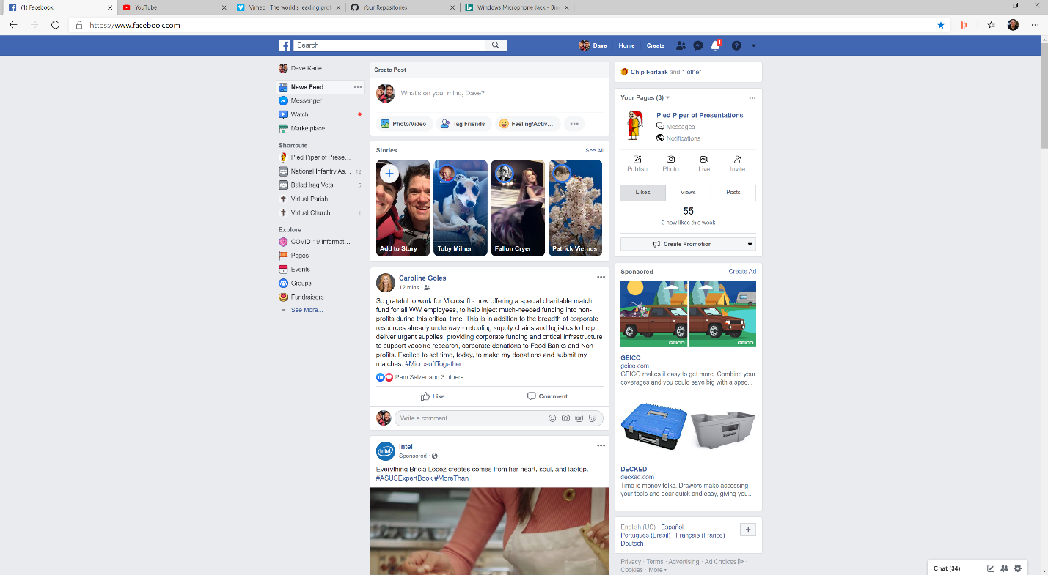

1. Navigate to the parish Facebook Page

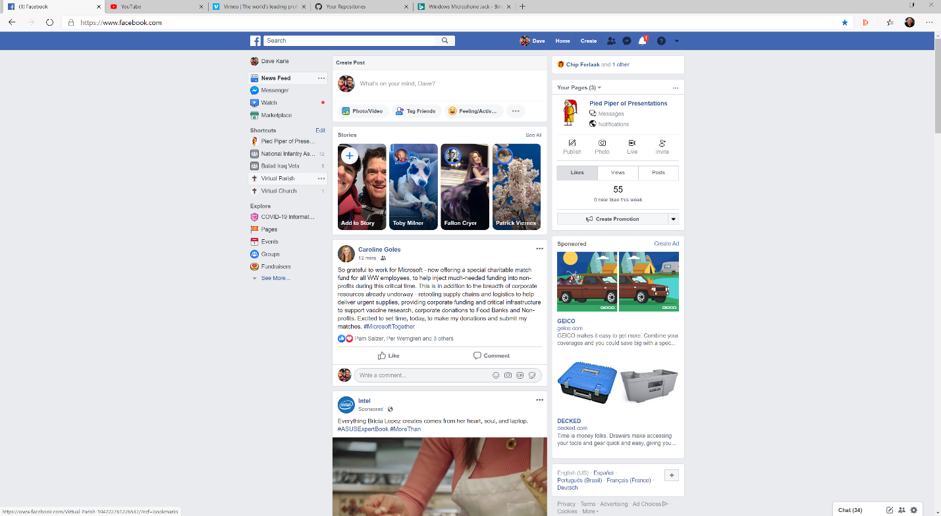

1. You are signed in and ready to go!

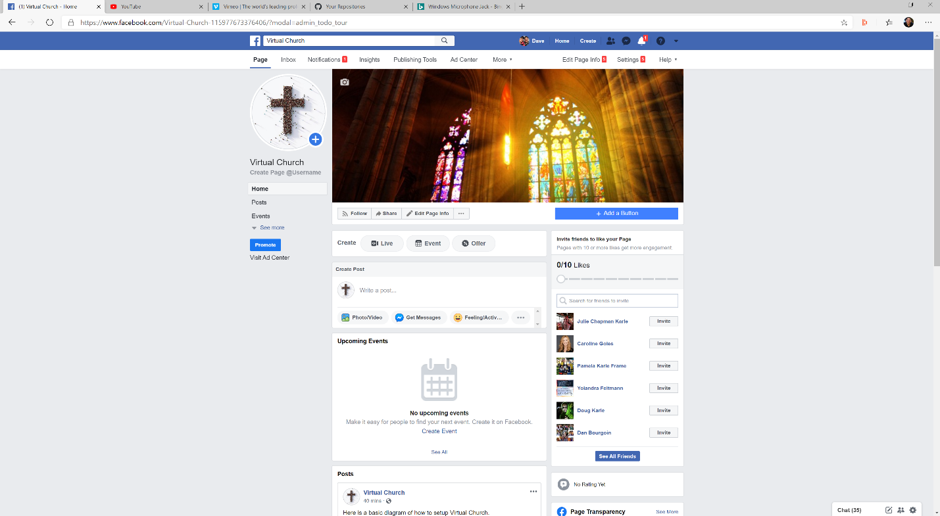

### Setup Events so Everyone Knows When Mass Is

1. From the Parish Facebook Home Page – click on Events on Left side



1. Click Create Event

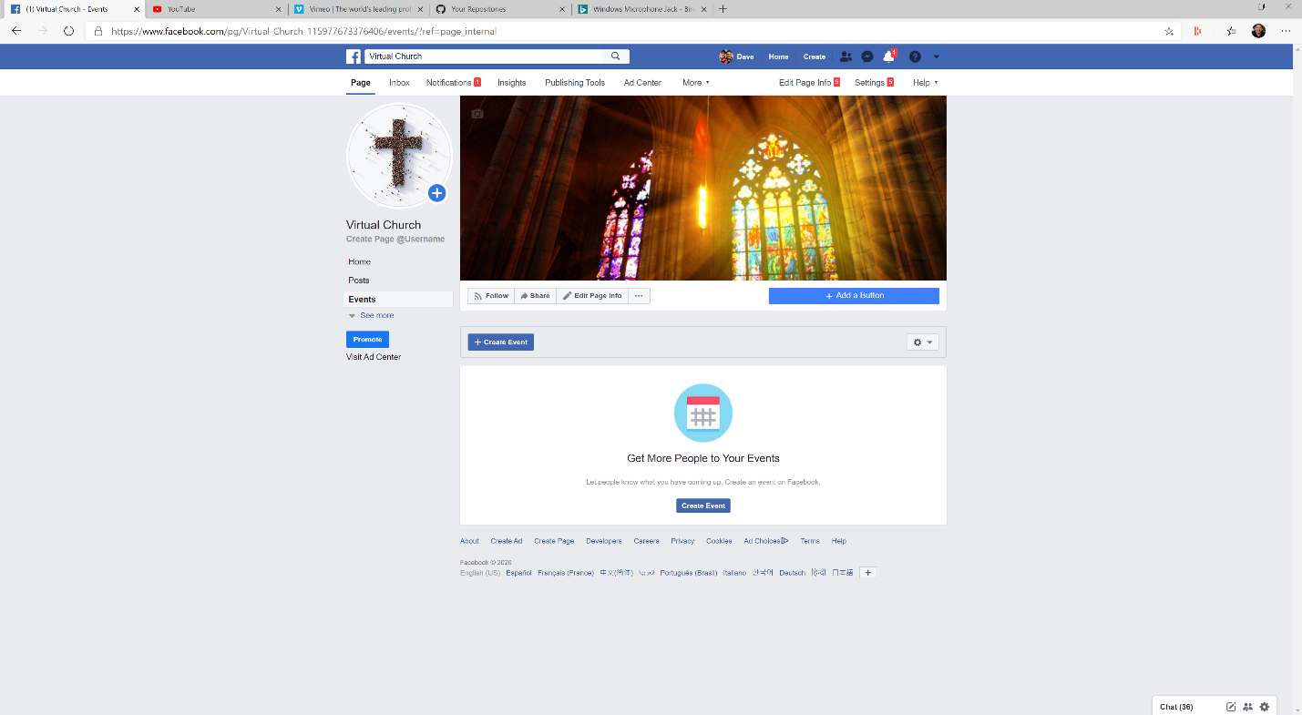

1. Fill out details and the click Publish

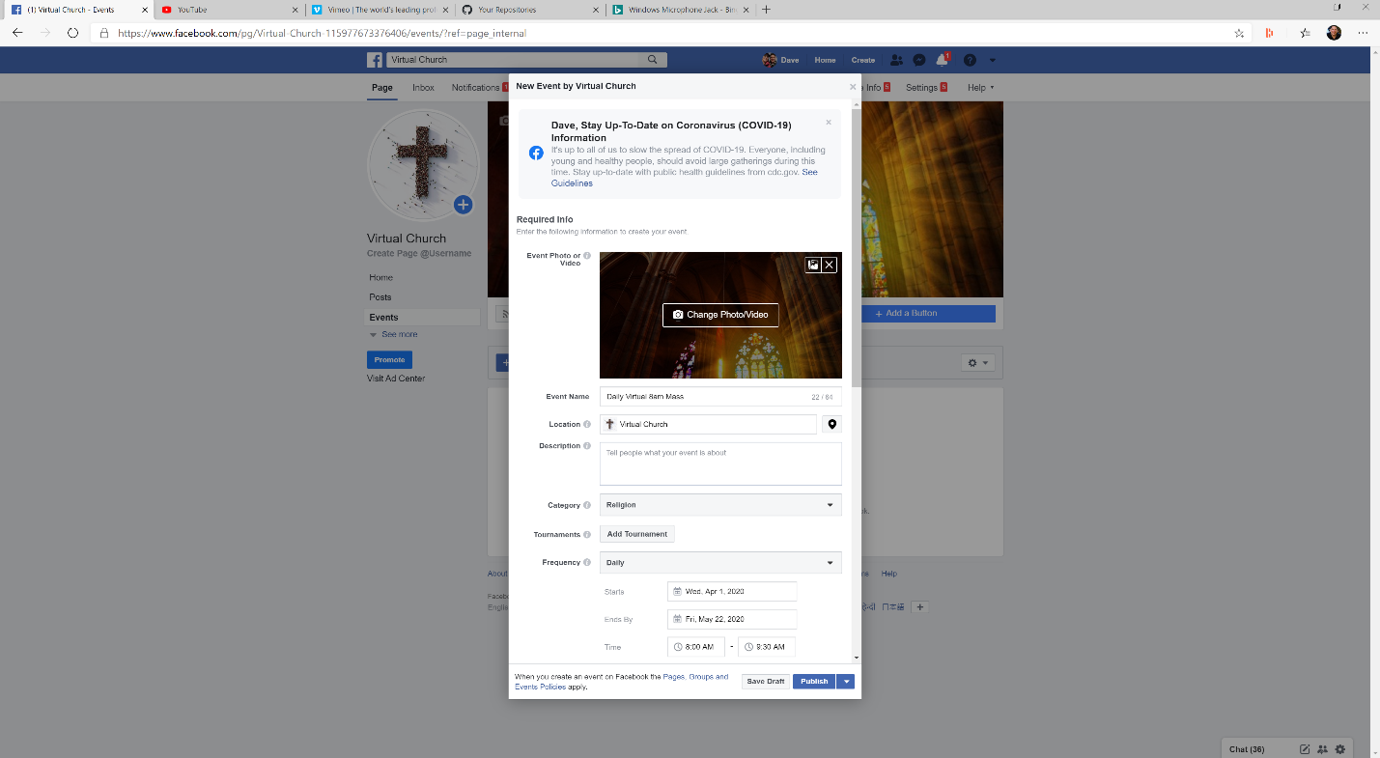

1. This is what the event should look like

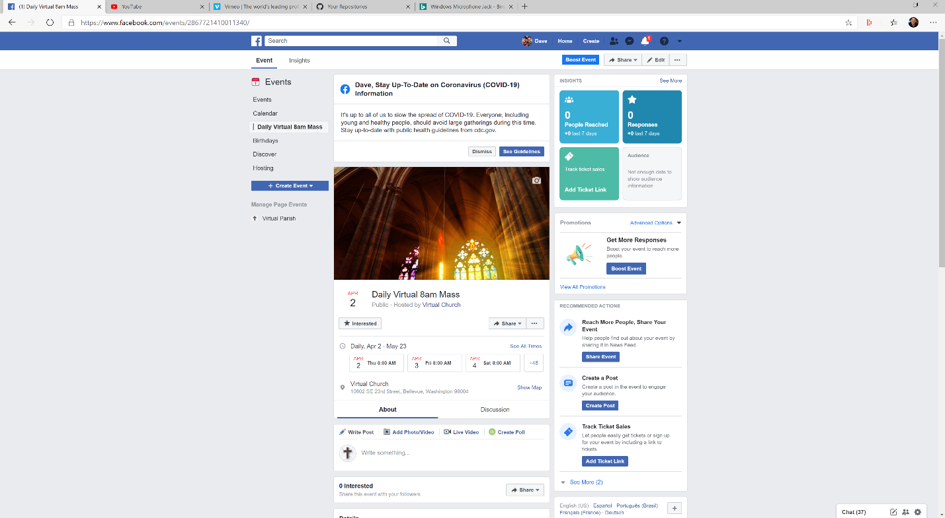

### Start Mass and Stream it Live and then Make the Recording Available for Later Viewing!

This assumes you are using Facebook Live and not Vimeo or YouTube.

1. From the Parish Facebook Home Page – Write a post saying Mass will start in 10 minutes and hit Post  
   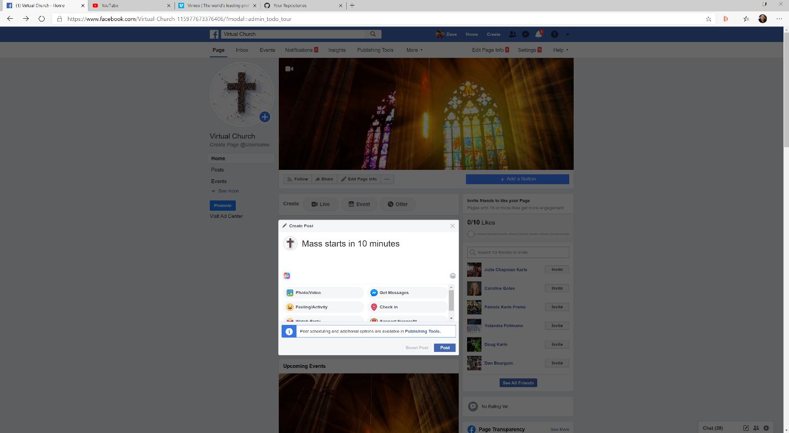
2. 5 Minutes before mass Click on Live Video Button

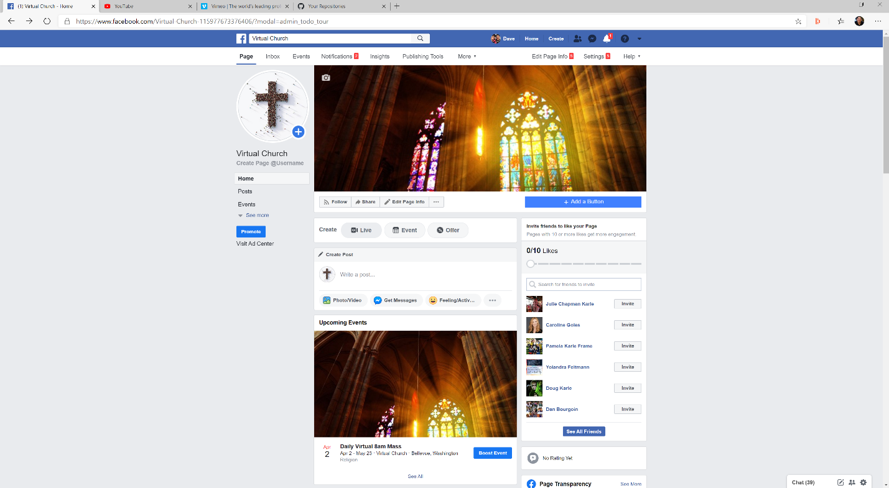

1. Change to your video and audio -> Open the list titled Use Stream Keys  
   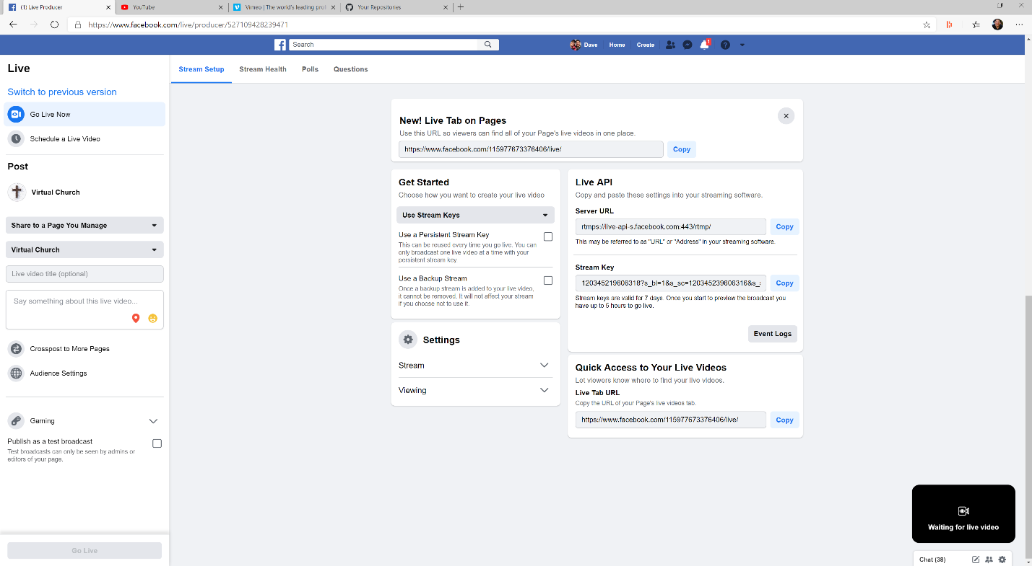
2. Choose Camera  
   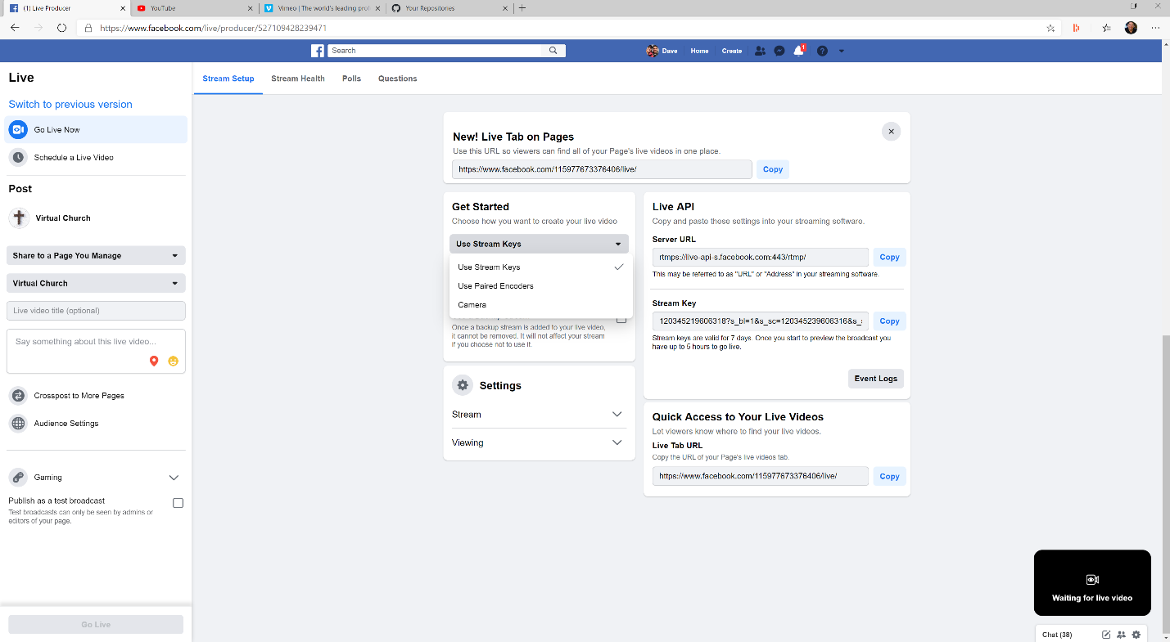
3. Select the webcam pointing towards the altar – you will see a preview in lower right corner  
   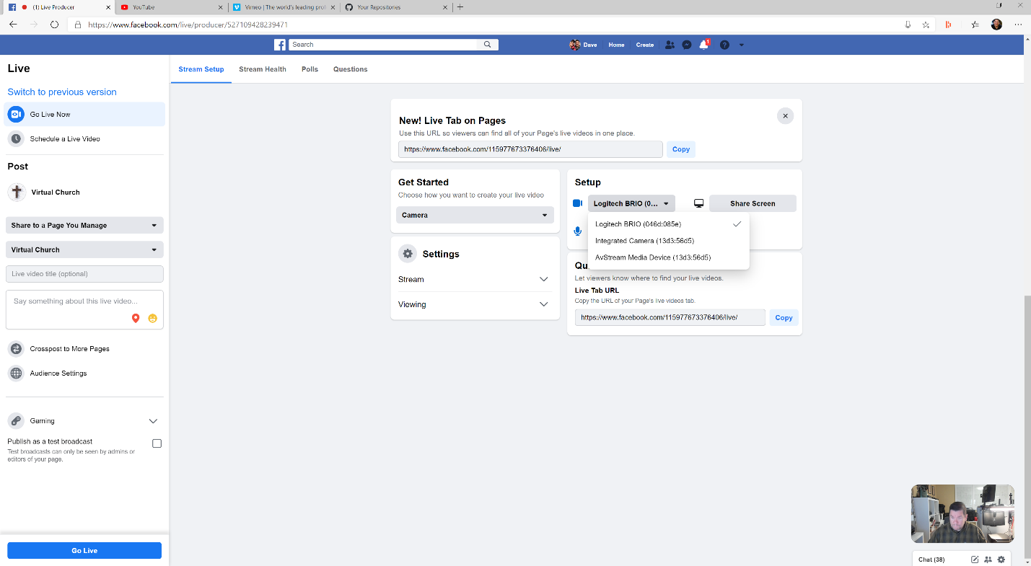
4. Select the micrphone that has the 3.5mm / 1/4in line in coming from the church sound system.  
   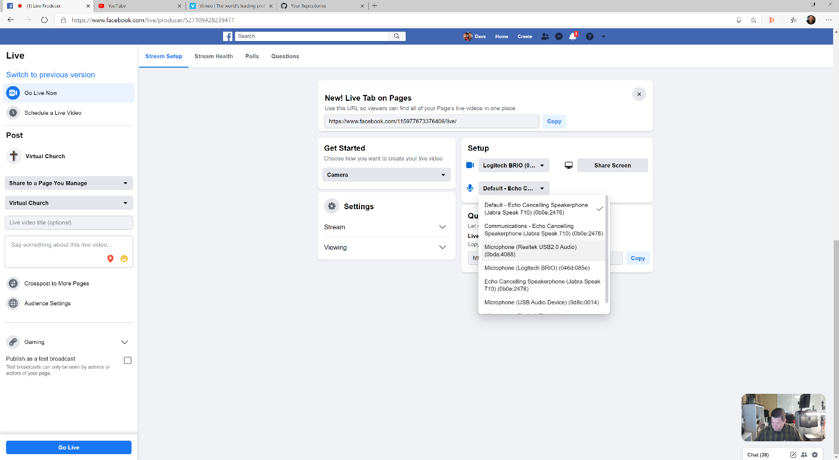
5. Click on Go Live Button (you are now live!)   
   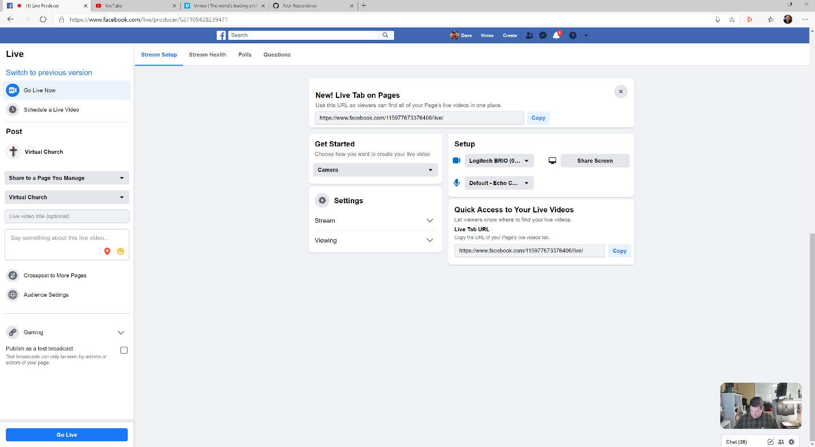
6. A certain percentage of time your camera will default back to the onboard camera, not the USB one. You just need to switch to the right camera.  
   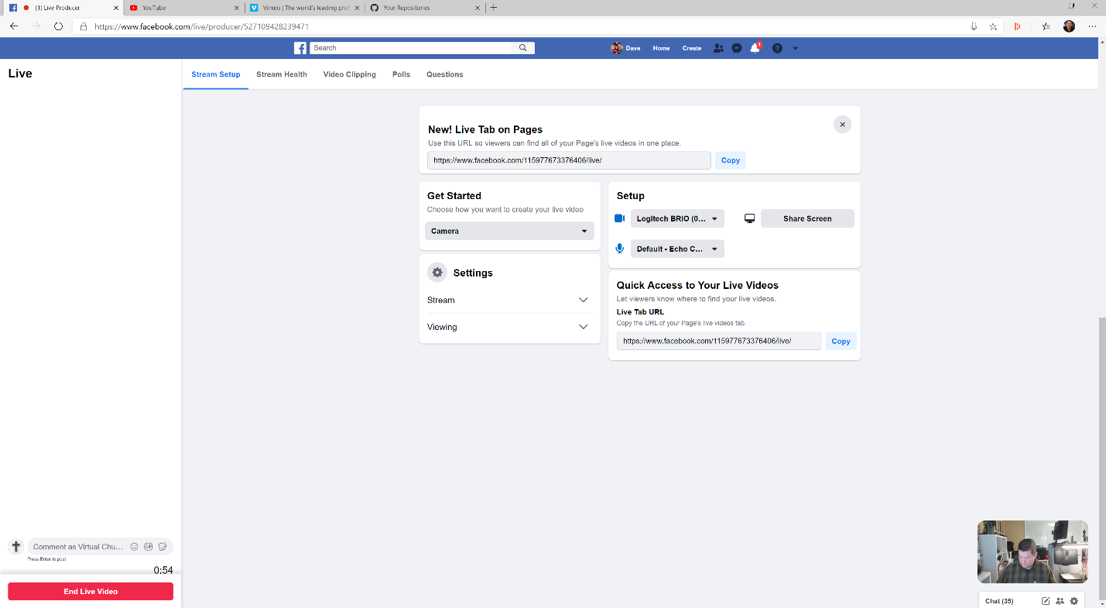
7. You are now streaming! – Monitor  
   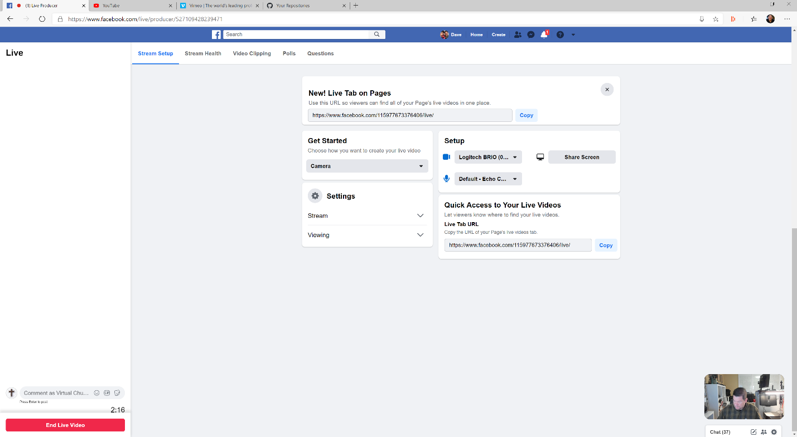

People will be posting comments. Helpers should respond.

1. Click End Live Video at the end of the Mass



1. Make sure video posts – might take as long as a half an hour after the event  
   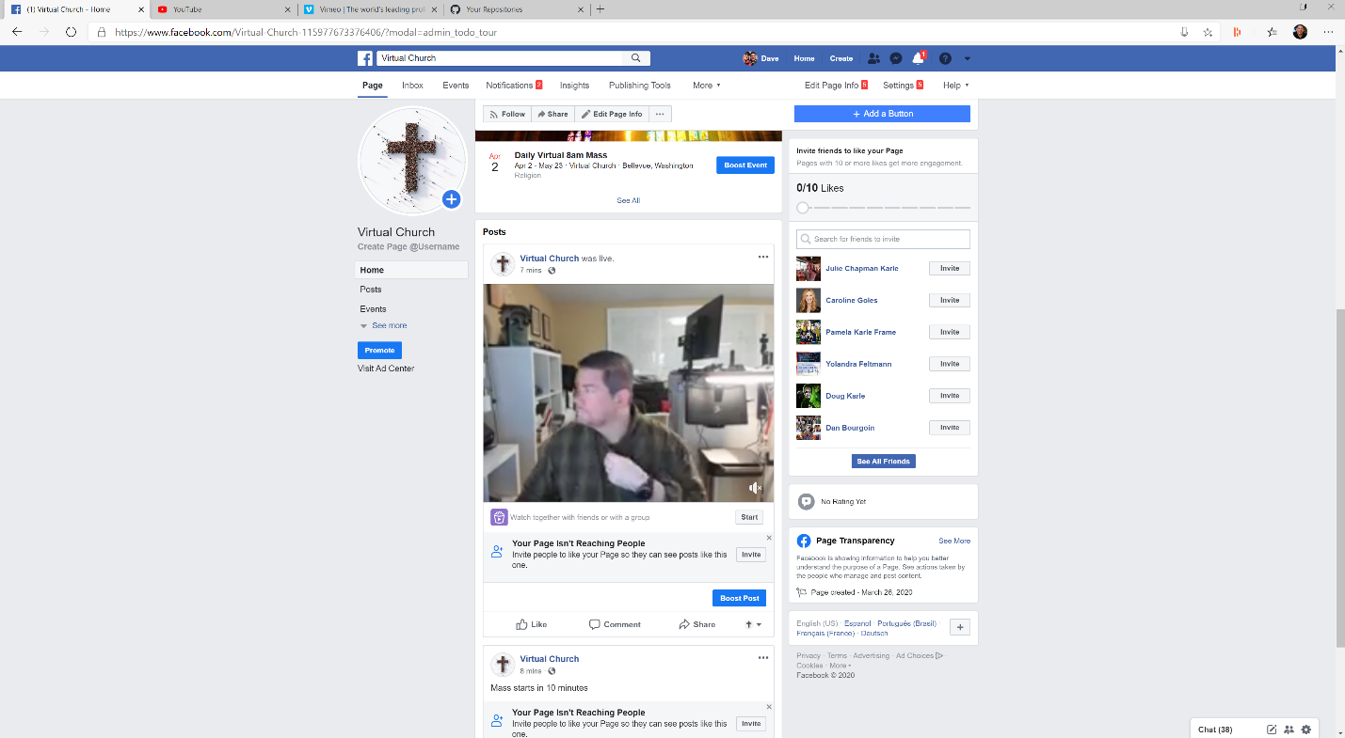
2. Share Video on Vimeo and YouTube

## Vimeo Setup

If you decide to use Vimeo, which allows for you to use 4K video, the sign up for a Vimeo account and bury your livestream link in the Facebook event post.

[Go here to find out more.](https://vimeo.com/features/livestreaming)

## YouTube Setup

If you decide to use YouTube, which allows for you to use 4K video, sign up for a YouTube account and bury your livestream link in the Facebook event post.

[Go here to find out more.](https://www.youtube.com/watch?v=ajRnToYSGyE)

## Camera Setup

### Webcam Guide

This is the easiest setup. Get the best webcam that you can, preferably 4K, and it should attach to the capture/streaming computer thru either standard USB or USB-C.

Here is the [Logitech Brio](https://www.logitech.com/en-us/product/brio?afsrc=1&cvosrc=affiliate.cj.9069228&cjevent=cb71ff316d2a11ea806100080a1c0e0c&adid=13528107&subacctname=Bing+Rebates+by+Microsoft) – one of the best and it’s 4K

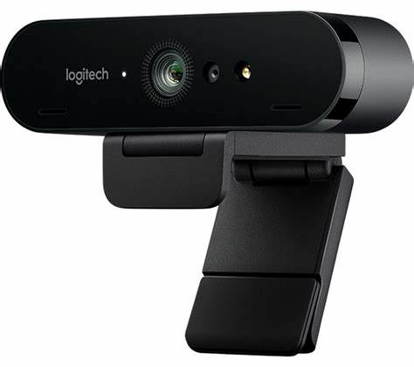

[Logitech C930](https://www.logitech.com/en-us/product/c930e-webcam?crid=34) – also excellent but only full HD

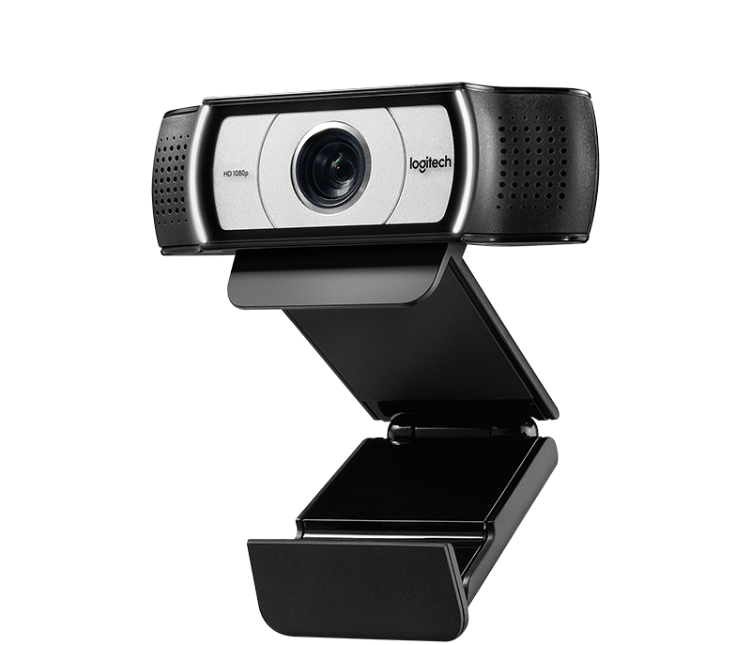

### DSLR/Video Camera Guide

Alternatively, you can use a DSLR or video camera to capture video.

Most of the time, you will need to either go video out on the camera thru HDMI to a HDMI to USB converter to get it into your computer as a livestream. [Go check this video out to see many of the options.](https://www.youtube.com/watch?v=gch4ReBTirI)

Make sure your device supports capture! Here are two good options [here](https://www.amazon.com/Capture-Recording-Adapter-Grabber-Windows/dp/B07FXHN43Y/ref=sr_1_3?keywords=hdmi+capture+to+usb&qid=1584988696&sr=8-3&swrs=2BB63BE9FF4ECC9DE72AECA0C3C59896) and [here](https://www.cdw.com/product/Elgato-Cam-Link-video-capture-adapter-USB-3.0/5538461?cm_cat=google&cm_ite=5538461&cm_pla=NA-NA-Corsair_MY&cm_ven=acquirgy&ef_id=CjwKCAjwvOHzBRBoEiwA48i6Av8ZwX5rptL2WIdyiIVkoUE0VU4bNkmBUomcww_InwJdmTaFbiNn-BoC5GUQAvD_BwE:G:s&gclid=CjwKCAjwvOHzBRBoEiwA48i6Av8ZwX5rptL2WIdyiIVkoUE0VU4bNkmBUomcww_InwJdmTaFbiNn-BoC5GUQAvD_BwE&s_kwcid=AL!4223!3!359169857231!!!g!316290835560!).

### Tripod, and camera placement.

You must put the camera on a tripod. Don’t try and hand hold. Position the camera so the entire upper alter area can be seen.

### Lighting

Ambient lighting should be enough. If you can get some lighting equipment of have a controllable lighting solution, a 3-light setup on the altar should work.

### Panning and Zooming

Don’t pan and zoom. It takes significant practice to be a good videographer and very expensive tripods and cameras. Just stick with the single shot of the altar and reading area.

## Audio Setup

As already noted you will have one of two environments at the output of your mixer, either XLR of 3.5mm / ¼ in. If you have XLR, you will need to get an XLR to 3.5mm converter [like this](https://www.amazon.com/gp/product/B00ZIY02VU/ref=ppx_yo_dt_b_asin_title_o02_s00?ie=UTF8&psc=1).

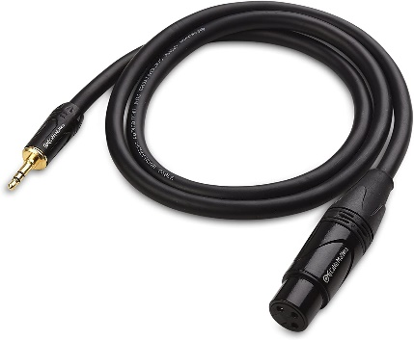

If you have 3.5mm you just need a long 3.5mm cable [like this](https://www.amazon.com/Movo-PM10EC6-Microphone-Extension-Smartphones/dp/B00X85S7EA/ref=lp_11973421_1_22?s=musical-instruments&ie=UTF8&qid=1584985236&sr=1-22).

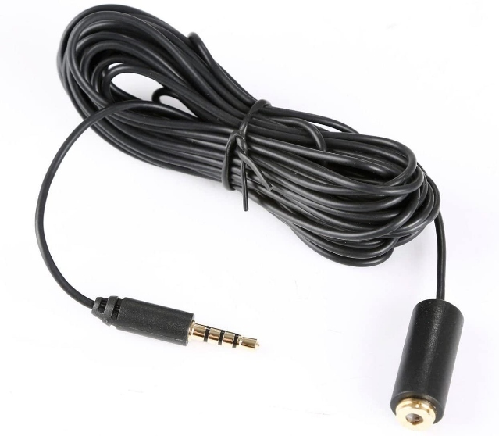

## Checklists

### Setup Checklist

1. Set Capture/Streaming PC/MacBook on Desk
2. Sign into Parish FB Page
3. Put tripod and camera in place and run video to PC
4. Put audio cables in place
5. Put microphones on tester
6. Put tester at altar
7. Test audio and video on PC
8. Do a test live video on FB
9. End
10. Make sure it posts
11. Delete
12. Tape all connections with Gaff tape
13. Tape all cables to floor with Gaff tape

### Morning of Mass Checklist

1. Sign into Parish FB Page on Capture/Streaming PC/MacBook on Desk
2. Put microphones on tester
3. Put tester at altar
4. Test audio and video on PC w/in FB page
5. Stream
6. End
7. Make sure it posts

## Troubleshooting

Sound is not streaming to the PC from the church sound system.

Video keeps switching from webcam that is pointed towards altar (webcam 1) to PC’s built in webcam (webcam 2)

**Sound is not streaming to the PC from the church sound system.**   
This is a super common problem. Here are some troubleshooting steps.

* 1. You need to make sure that the 3.5mm/ 1/4in line in is securely pluged into the proper computer port. It is the microphone port.  
     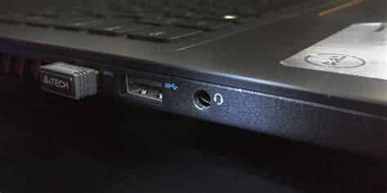
  2. Tape everything in place with Gaff tape. This will make sure there is no loose connection. Gaff tape is cloth backed tape and you probably have some lying around.  
     
  3. Make sure that you PC is setup to use the sound coming from that port. In the Cornata button on the lower left type in Control Panel.   
     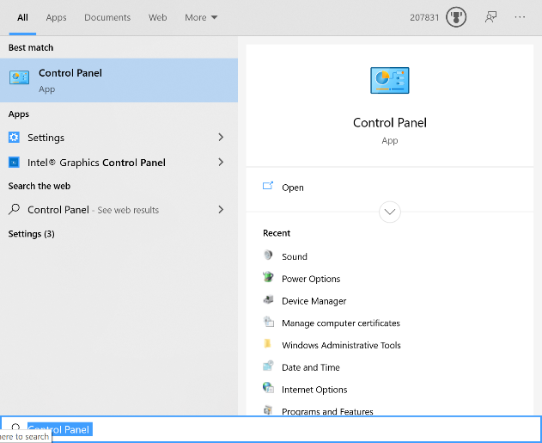
  4. One the Control Panel is open type Sound in the search bar and hit Enter.  
     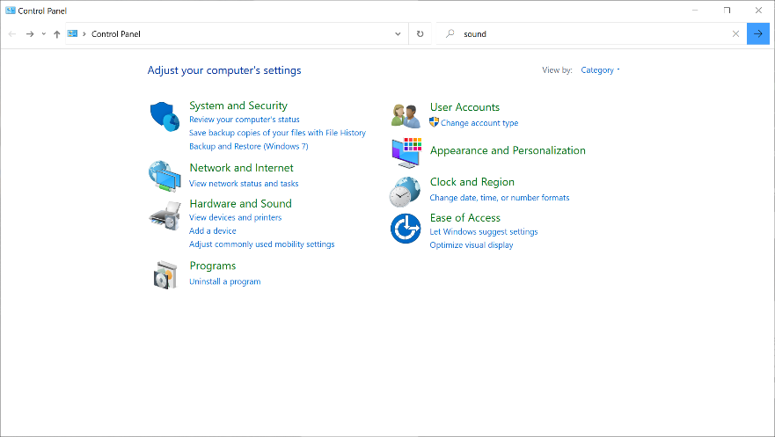
  5. Click on Sound  
     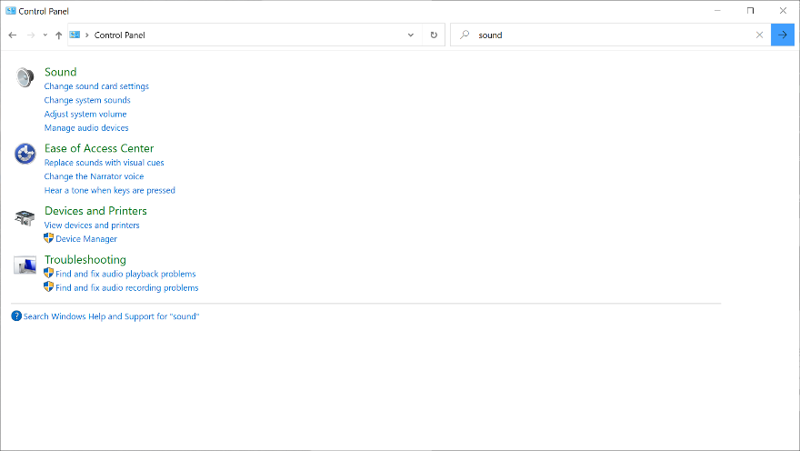
  6. When the sound dialog come up, Click on the Recording Tab and you will see that there are a bunch of microphones.   
     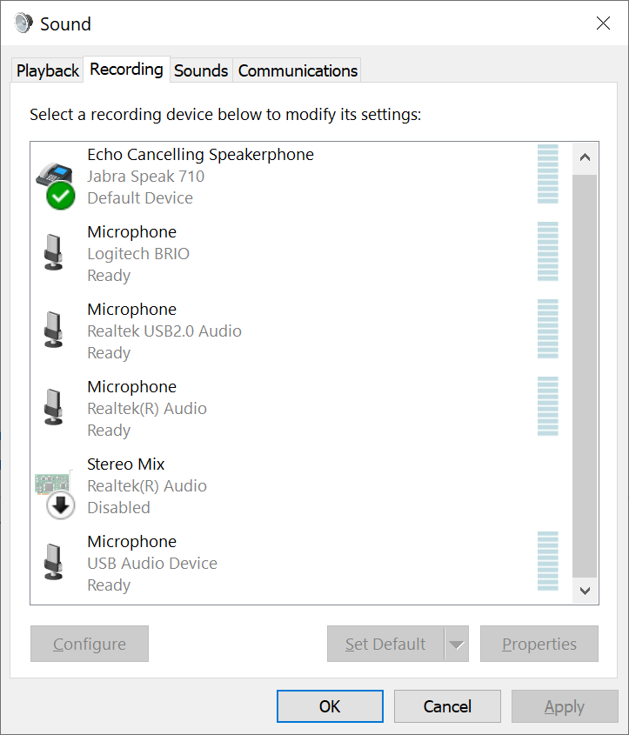
  7. Usually the one that is attached to the Microphone jack is the Realtek Audio jack.   
     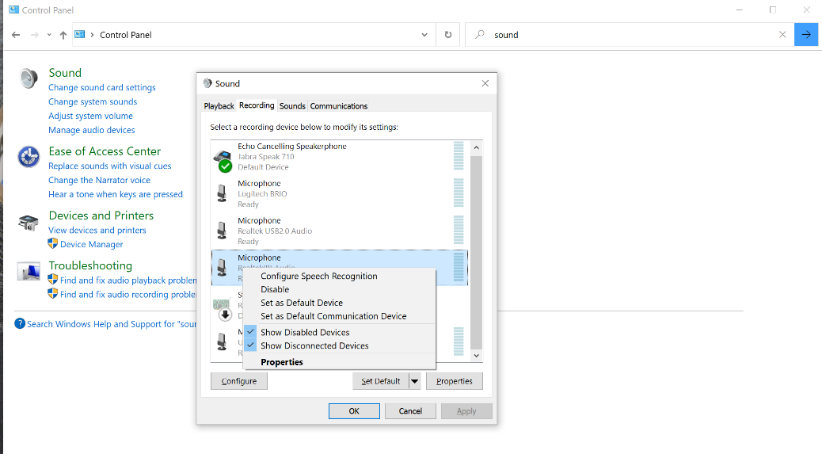
  8. Set that microphone as BOTH the Default Device and the Default Communication Device.
  9. You might have to try this with different microphones on your PC to get it to work!

**Video keeps switching from webcam that is pointed towards altar (webcam 1) to PC’s built in webcam (webcam 2)**

When you start a Facebook Live session and choose Go Live, on PCs it will sometimes switch from the webcam that you attached via USB to the onboard webcam. You just need to go into the camera setting and switch back.